**KAMPALA URBAN SCHOOLS**

**BEGINNING OF FEBRUARY EXAMINATIONS, 2024**

**PRIMARY SEVEN INTEGRATED SCIENCE**

**NAME: _________________________________________STREAM: _______**

**SECTION A**

1. What is adolescence?

_________________________________________________________________

1. Name one-night insect pollinator of flowers.

_________________________________________________________________

1. How do farmer care for their crops in the dry season?

_________________________________________________________________

1. Apart from the queen bee, give one other member of a bee colony.

_________________________________________________________________

1. By what process do plant roots absorb water from the soil?

_________________________________________________________________

1. What food nutrient is lacking in the body of a child whose diagram is shown.

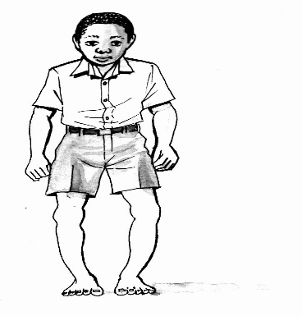

_________________________________________________________________

1. Mention one method of preserving milk.

_________________________________________________________________

1. Why can’t mushrooms make their own food?

_________________________________________________________________

1. How does yeast reproduce?

_________________________________________________________________

1. Which body organ is protected by the skull?

_________________________________________________________________

1. **In the space provided below, draw a compound leaf.**
2. Oponyo has severe diarrhoea which has lasted a week. How can this condition be treated?

________________________________________________________________

1. Explain one advantage of grafting as a method of plant propagation.

_________________________________________________________________

1. Name one part found on the thorax of an insect.

_________________________________________________________________

1. Maria got a contract of supplying eggs to Hotel Africana. What type of chicken should she rear?

_________________________________________________________________

1. How is the endosperm of a maize grain similar to the cotyledon of a bean seed in terms of function?

_________________________________________________________________

1. How is soap useful in promoting personal hygiene?

_________________________________________________________________

1. How can infants acquire immunity?

_________________________________________________________________

**The diagram below shows part of a flower.** Use it to answer question 19.

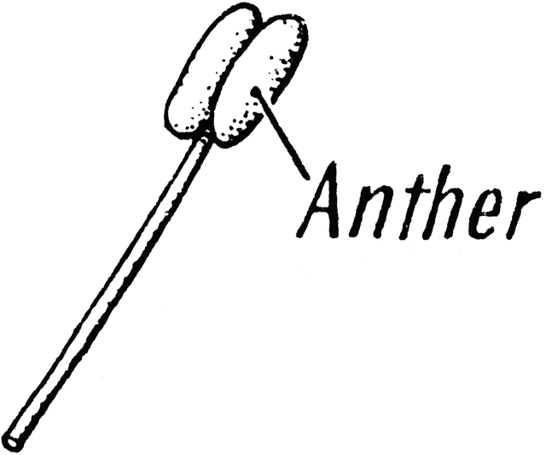

Filament

1. How is the above part important in the reproduction of a plant?

_________________________________________________________________

1. Identify one layer of a soil profile.

_________________________________________________________________

1. Give one example of a PIASCY message.

_________________________________________________________________

1. Most farmers who keep local cattle rear bullocks. Give a reason for this practice.

_________________________________________________________________

1. In which part of the digestive system of mammals does chemical digestion end?

_________________________________________________________________

1. Why does most of the photosynthesis process take place during day time?

_________________________________________________________________

1. 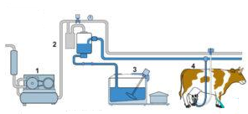Besides the method of milking shown below, state another method of milking cows.

_________________________________________________________________

1. Name one respiratory disease immunized against using the DPT vaccine.

_________________________________________________________________

1. Mention one activity that primary six pupils should do to promote personal hygiene.

_________________________________________________________________

1. Why would it be dangerous to fill oxygen in fire extinguishers?

_________________________________________________________________

1. Who is a “casualty” in relation to human health?

_________________________________________________________________

1. Give one role of a father at home.

_________________________________________________________________

1. Name one example of root crops.

_________________________________________________________________

1. Why is silk said to be a resource?

_________________________________________________________________

1. Why do you iron school uniforms?

_________________________________________________________________

1. Why would one encourage community members to harvest rain water?

_________________________________________________________________

1. Name the basic unit of measuring the mass of an object.

_________________________________________________________________

1. Give one cattle disease caused by a protozoon.

_________________________________________________________________

1. State one example of a heat insulator.

_________________________________________________________________

**Study the diagram below and answer questions 38**.

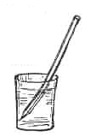

**Metallic ruler**

**Hot water**

**S**

1. By what process does heat travel from the hot water to point S on the ruler.

_________________________________________________________________

1. Why do crop farmers dislike caterpillars?

_________________________________________________________________

1. Give the importance of the Stevenson’s screen at a weather station.

_________________________________________________________________

**SECTION B (60 MARKS)**

1. The diagram below is of a mammalian heart.

**B**

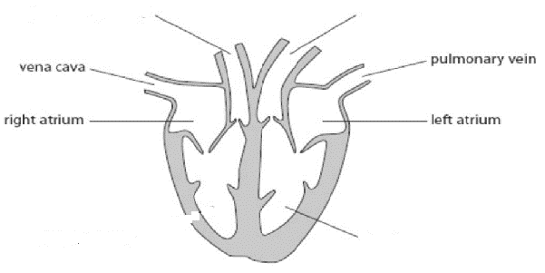

**C**

**A**

(a) What is the main function of the heart?

_____________________________________________________________________

(b) Name the parts marked A and C

A_________________________________C____________________________

(c) Use arrows to show the flow of deoxygenated blood through the heart drawn above.

1. 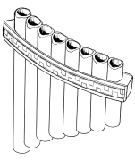(a) **The diagram shows a musical instrument.**

**1**

**8**

1. To which group of musical instruments does it belong? ______________________________________________________________
2. Why does pipe 8 above produce sound of the highest pitch?

_________________________________________________________________

(b) Calculate the volume of the figure below. (2mks)

3cm

2cm

6cm

1. (a) What is seed dispersal?

_________________________________________________________________

(b) State the agents of seed dispersal for the following seeds/fruits.

**iii**

**i**

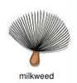  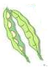

**ii**

(i)_______________________(ii)__________________(iii)________________

1. **The diagram below shows immunization schedule table. Use it to answer the questions that follow.**

|  |  |  |  |
| --- | --- | --- | --- |
| **Disease** | **Vaccine** | **Age** | **Site** |
| Polio | ______________ | birth | Mouth |
| _______________ | Measles vaccine | 9 months | left upper arm |
| Diphtheria | DPT | 6 weeks, 10 weeks | _____________ |
| Tuberculosis | BCG | _______________ | Right upper arm |

1. (a) What is firs aid?________________________________________________

_________________________________________________________________

(b) Why should an accident victim be given first aid as soon as possible?

_________________________________________________________________

(c) Give one use of the following items when giving first aid:

(i) splints_________________________________________________________

(ii) methylated spirit ________________________________________________

1. (a) What is Apiculture? _____________________________________________

_________________________________________________________________

(b) How are drone bees useful in a bee colony?

________________________________________________________________

(b) Write down two duties of worker bees in a hive.

(i)_______________________________________________________________

(ii)______________________________________________________________

1. (a) List down two examples of non-communicable diseases.

(i)___________________________ (ii)___________________________

(b) Give one way of preventing non-communicable diseases in our society.

_________________________________________________________________

(c) Name one disease spread through open cuts and wounds.

_________________________________________________________________

1. (a) Give the importance of the following body organs.
2. Heart: ________________________________________________________
3. Lungs ________________________________________________________
4. Kidneys:_______________________________________________________
5. Skin:_________________________________________________________
6. **The diagram below shows two people. Use it to answer the given questions.**

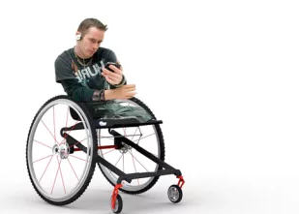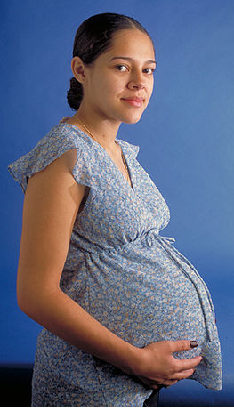

**W**

**M**

1. Who of the two people above is vulnerable?

________________________________________________________________

(b) Give a reason to support your answer in (a) above.

_________________________________________________________________

1. How is a wheel chair important to person M?

_________________________________________________________________

1. State one way of caring for person W at home.

_________________________________________________________________

1. (a) Why are squirrels said to be crop pests?

________________________________________________________________

(b) Give two ways by which farmers can control crop pests.

(i)_______________________________________________________________

(ii)______________________________________________________________

(c)Give one effect of crop pests.

_________________________________________________________________

1. **(a) Match the weather instruments to their uses correctly.**

**Weather instrument use**

Rain gauge shows direction of wind

Hygrometer measures air pressure

Wind cock measures the amount of rainfall

Barometer measures humidity

**Weather instrument use**

Rain gauge __________________________________________

Hygrometer __________________________________________

Wind cock __________________________________________

Barometer _________________________________________

1. **Study the diagram of the leaf below and use it to answer the following questions.**

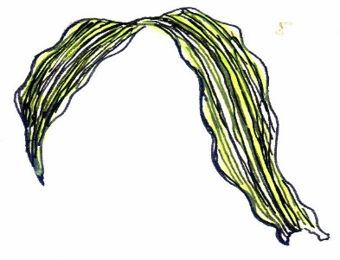

(a) Name the type of leaf venation shown.

________________________________________________________________

(b) In which group of flowering plants do we find such a leaf?

________________________________________________________________

c) Outline two uses of leaves to people.

(i)_______________________________________________________________

(ii)______________________________________________________________

1. **(a) Fish is perishable food and therefore needs to be preserved.** Mention two ways of preserving it.

(i)____________________________(ii)________________________________

(b) How can food get contaminated?

_________________________________________________________________

(c) Why should one wash hands before serving food?

_________________________________________________________________

1. **Use the diagram below to answer the questions that follow.**

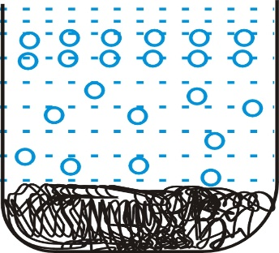

**Lump of soil**

**Air bubble**

**Water**

(a) What does the experiment above prove about soil?

_______________________________________________________________

(b) Name one soil organism.

_________________________________________________________________

(c) How is soil useful to man?

_________________________________________________________________

(d) Apart from air, give one other inorganic component of soil.

________________________________________________________________

1. **The pictures below show people smoking shisha.**

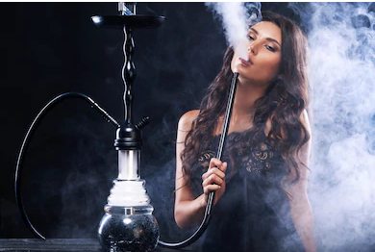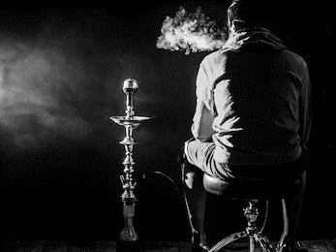

(a)What type of smoking is shown above?

________________________________________________________________

(b) Apart from shisha, name any one other drug commonly abused in our society.

________________________________________________________________

(c) State one danger such people are likely to experience.

________________________________________________________________

(d)How can you help such friends to avoid the danger mentioned above?

________________________________________________________________